**Cornelius**

Cornelius is an incredible charismatic man. What he lacks in physical strength he makes up for with cunning deception and greed. He is originally from Emberhill and moved to Frostalon after a bitter break up. On arriving the town he saw a fragile setting fit for the right person to slot themselves into power. He quickly became acquainted with Amadeus Hunter, 40 years ago, the owner of the large hunting good supplier in the town and ingratiated himself with Amadeus’s granddaughter Lyndsay Hunter. He then set up a small bar from which he co-ordinated his work, the Cold Companian, named similar to the Frigid Friend, so to steal some of the business from the odd traveller.

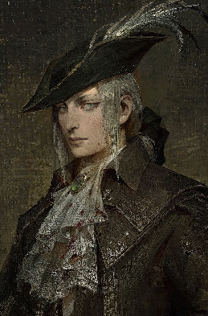

Cornelius then advised Amadeus to hunt a snow leopard and with the pelt Cornelius would travel the theatre showing off the mighty pelt to the world. When he travelled he told the world about ‘The Cornelius Foundation’ the only way to get this miraculous pelt. When trade started to arrive in Frostalon Lyndsay Hunter introduced the travellers to the foundation taking care of their basic needs and trading pelt at extortionate prices.

While travelling with the pelt Cornelius gained a small amount of magical ability, abilities he attributed to handling the pelt all day. When he returned to Frostalon Lyndsay, 10 years later, had followed his instructions but also, being entrepreneurial spirit herself, had claimed a lot more of the business in Frostalon by securing a marriage with the main trader Joseph Burrow, now becoming Lyndsay Burrow.

With the trade of pelts entwined with the income of food and supplies Lyndsay and Cornelius had a choke hold on the town. The old guard captain was feeble in his attempt to stop the pair and ended up freezing in the cold when investigating their newest venture.

Cornelius found more and more that the pelt gave a level of magical ability. He hired a person he met on his travels named Octus. Octus arrived in the town and immediately began experimenting on the meat and pelt from the leopards and discovered that when chemically prepared in a specific way granted the user a near endless supply of magical potential. This process was costly but a ruin was found in the cold by several hunters which promises to cheapen the preparation process

To protect the assets of the business and the new experimental component of the foundation, Cornelius hired Tarnall a suave gentleman from the capital. Tarnall then hired Geshelle and Othello and most recently Falcon.

Eventually Cornelius intends to open a school in Frostalon, using the blood to accelerate the learning of young sorcerers and wizards, hiring Sasha to oversee this.

**Lyndsay Burrow**

Lyndsay, born Lyndsay Hunter fell for a new comer to the town but she did not fall for his naïve nature or his stunning good looks, she was a woman of business and saw that same drive in Cornelius’ eyes. He became acquainted with her father, Amadeus Hunter, and the intricacies of their business while he ran a small bar on the southern arm of Frostalon. Finally she heard that he had attempted to convince Amadeus to hunt a snow leopard, a creature much more fierce than the wolves and rabbits that they were accustomed to hunting. Thankfully Lyndsay had many cousins as the Hunters are a sizable family. She decided to lead them on a hunt with more than 36 men. The weeks in the cold were gruelling, they lost 4 from the cold alone.

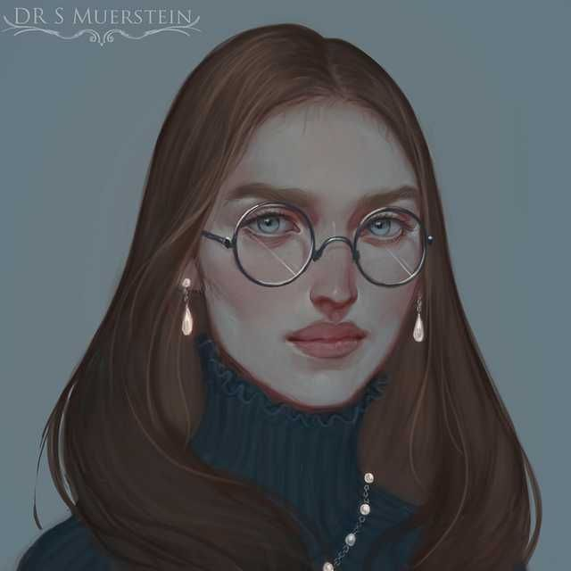

Finally on the fourth week in the cold on the edge of returning the spotted one of the illusive creatures. The fight was hard fought and as the moon rose they slay the creature and skinned it there in the snow, only 6 of the men returned and the whole town went into mourning. Cornelius left to travel and advertise the pelt, leaving explicit instructions for Lyndsay to maintain the business and to weasel more power from her father.

The years Cornelius was gone were long and much of his guide came to fruition but much of the guide was useless and she improvised. Several months before Cornelius was to return her father was swithering to disband the business as the import cost of the hunting equipment was becoming unmanageable. Lyndsay wooed her, now husband, Joseph Burrow, and in marrying her joined the businesses to secure the hunting business’s future.

Cornelius had not returned to the town but people began to appear ready to hunt for the ‘Cornelius Foundation’ Lyndsay began the foundation from her lover’s old bar. Finally he returned and after some arguments they laid out plans for the future. Soon, with the staffing available Lyndsay was able to convince her father to hire directly from Cornelius and with the growing demand they cemented the trifecta. Finally as The Cornelius Foundation was known beyond the township Joseph, and Amadeus named their combined enterprise The Cornelius Foundation.

The old guard became suspicious of their activity, especially after a shortage of food for the whole town after Cornelius failed to order the correct supplies from Emberhill. The captain interrogated Lyndsay and she let slip that Cornelius had a secret project in the cold a days travel north east under the crooked cliff. Lyndsay and Garthe were child hood friends and with his senior position in the guard the captain did not trust his own men so decided to investigate himself He did not reach the site.

Lyndsay now runs her elder father’s business to handle the finances of the Cornelius’ Foundation as he is infirmed and Joseph, getting older too relies on her and Cornelius to organise the sole delivery service in Frostalon.

**Octus**

Octus belongs to a creed from the Theatre Capital called the Understudies. The Understudies are made of people found with exceptional aptitude in a particular field at a young age. They are kidnapped and brought to the capital then solely trained to preform that purpose, they are marked with the following tattoo. Octus is a short Dwarf with a wide brim hat, he carries many explicit chemical outlawed in most of the theatre. His interest is entirely alchemical and while in the capital he met Cornelius.

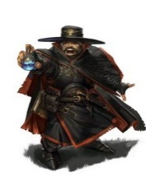

Cornelius had a pelt from a creature Octus had heard about from the books of the Understudies. He took a sample while the young man was traveling in the capital and found it had remarkable properties worth investigating. He lost favour with the Understudies after an explosion in the capitol that cost 4 lives the organisation had to cover up. When eventually Cornelus asked the dwarf to come to Frostalon to investigate the pelt Octus jumped at the opportunity, not sure how knowledgeable Cornelius was about the pelt that Octus had stolen some of it.

Finally when Octus arrived in Frostalon he was given nearly anything he needed to perform his investigation including endless samples and soon found that when exposed to concentrated moonlight on limestone the blood of the creature began to boil. This released an explosive amount of magical potential, with modification the reaction could be help after exposure to the light, granting an individual nearby incredible magical abilities.

Octus, weary of his past and the potential of this discovery advised Cornelius to hire a group of investigators and security force. After consulting with Lyndsay Burrow and Cornelius Octus managed to convince them to hire Lucile and Tarnell. Two individuals from Octus’ past, one a cold hearted killer from the Barbaric Plains of Nectal, and the other a local who showed incredible credit in chemistry according to Octus. The local, Lucile was the daughter of Garthe, a friend of Lyndsay’s and was instrumental in finding the structure beneath the crooked cliffs.